Samsung Galaxy Note 8

Type of device: Mobile
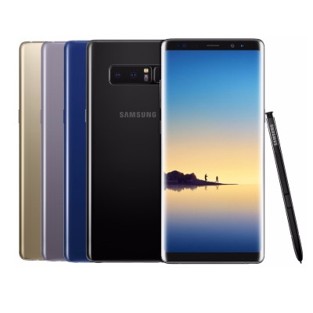

Actual Display Size : 6.3"
Button Type : Touchscreen
Operating System : Android
Version Number : 7
Network Capability : 3G,4G
Year of Release : 2017
Average Price : $419 as of 18 05 2021

Accessibility Features:

Cognitive
- Additional Instructions
- Copy and Paste
- GPS
- Photo Telephone List
- Screen Timeout Disabled
- Simple Instructions
- Simple Reminders
- Simplify Display
Voice Notes

Hearing Impairment and Deaf
- Allows for sign language communication
- Bluetooth or Wi-Fi
- Closed Captioning
- Front Facing Camera
- Hearing Aid Microphone Coupling
- Hearing Aid Telecoil Coupling
- Text Messaging/SMS
- Vibrating Alerts - Adjustable
- Video Communications - Two-way
Visual Alerts - Incoming Calls

Vision
- Battery Alert - Audible
- Bluetooth or Wi-Fi
- Brightness Adjustable
- Dictation / Speech-to-Text
- High Contrast Mode
- Power Cue
- Screen Magnifier
- Screen Reader
- Text Size Adjustable
- Text Style Adjustable
- Voice Control /Personal Assistant
Voiced Menus

Speech
- Allows for sign language communication
- Bluetooth or Wi-Fi
- Messaging Options - Email
- Messaging Options - IM
- Messaging Options - MMS
- Predictive Text
SMS Personalisation and Reuse

Physical
- Automatic Answer
- Bluetooth or Wi-Fi
- Dictation / Speech-to-Text
- Flat Back for Table Top Operation
- Headset - plug connected
- Predictive Text
- Speaker-phone option
- Stylus or Prosthetic Device support
- Switch control option
- Voice Control / Personal Assistant
- Voice Recognition for Accessing Features
Voice Recognition for Dialling

How and where to get it from?
You can buy this phone from Mobileciti, Dick Smith, and other retailers.

More information is available on:
Samsung Galaxy Note8 Web Page
Samsung Galaxy Note8 User Manual (PDF Download)

